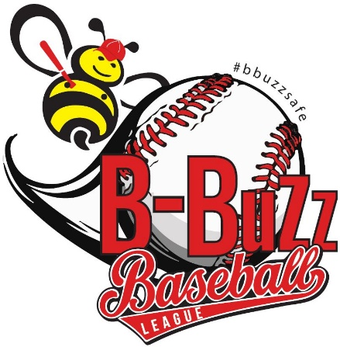

The B Buzz Baseball League has enriched the lives of young people in the Lee-Harvard and surrounding communities for over 50 years. This American pastime and community sport has also united neighbors and created lifelong friendships between past B Buzz alumni.

B Buzz Baseball League has a mission that is committed to the personal and athletic development of all its players. The league does not simply focus on the fundamentals of the game, like team play and leadership attributes, but through its broader purpose, the league provides wrap-around community resource services and opportunities for everyone involved.

Since our re-establishment in 2015, and becoming a 501c3 non profit organization, the league has partnered with community organizations, social service programs, summer library reading programs and many more initiatives to better prepare our players for a brighter future.

These resources are not just offered to the players, but the entire family can benefit from these resources as well. B Buzz is more than a youth baseball league, we strive to contribute to building superior citizens rather than superior athletes, with a goal of enriching the community along the way, all while having Big Fun playing the game of baseball !

The adult and youth coaching staff and volunteers that support B Buzz have all once played in the league as a young person, or were in the stands supporting family and friends many years ago and still carry the desire to support the leagues efforts in every way.

Our Board of Directors and Advisory Board is composed of city Mayors, business owners, former professional athletes, current educators, college students, and many other B Buzz alumni who are fully committed to a successful future for the league.

Our sponsors and our alumni make it financially possible for our league to function which has aided in growth of our program thus far.

